Bliss’s Summer Reading Assignment

This summer, you will be reading The BFG by Roald Dahl.That is all you have to do… READ! We will be doing fun activities the first week of school that will test your knowledge of the book.

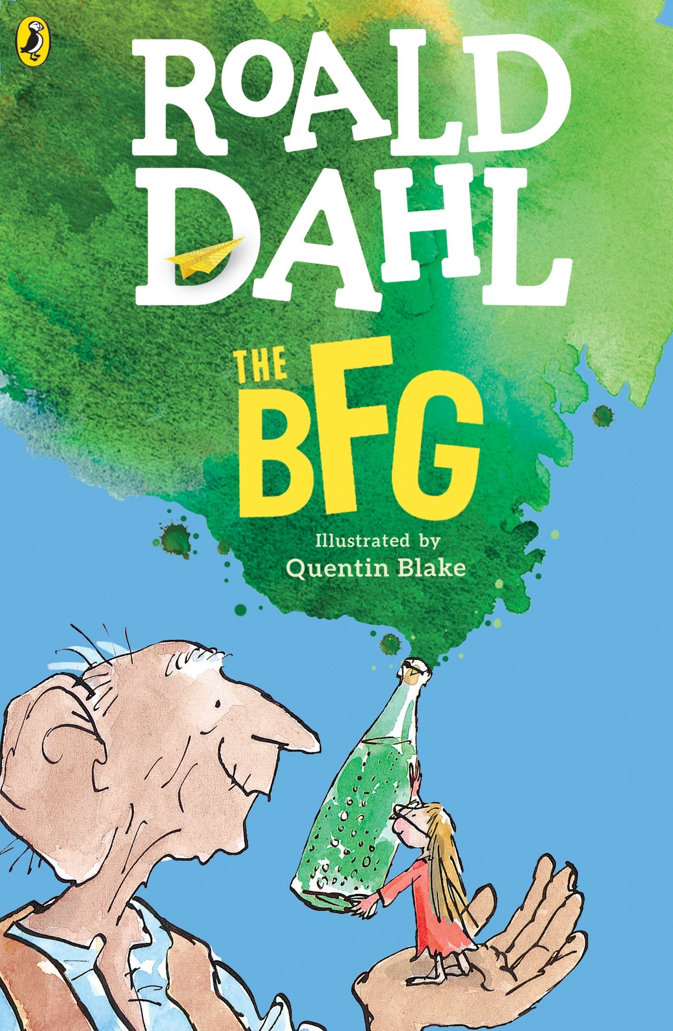

**Challenge**
Read additional books, comics, articles on educational websites, audio books, e-books, etc.
Examples: Who Was or What was books, Marvel/DC comics, https://www.timeforkids.com/

I encourage you to READ, READ, READ!

